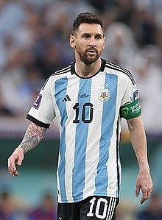LIONEL MESSI

Until leaving the club in 2021, he had spent his entire professional career with Barcelona, where he won a club-record 34 trophies, including ten La Liga titles, seven Copa del Rey titles and three UEFA Champions Leagues. With his country, he won the 2021 Copa América and the 2022 FIFA World Cup.

# Work experience

* **In FC Bareclona Club**

I’m a key player in team. And my first much with Barcelona in 2006. That time I have shooted one goal.

Untill 2021 before I leave Barcelona team, I have won a lot of trophies like UCL 4, Laliga10...

* In Paris satiman

I joinh with PSG in 2022. All people in the world always call him that goat.

In PSG he also win the trophy, but he don’t win UCL.

* In national club

In 2021, I won a COPA American trophy.

And 2022, My international club joined world cup in Qatar. And than I won world cup trophy.

# Skill professional

* The best player in the world
* The top of Barcelona club

# Manager in team

* Capitan in FC Barcelona Club

Whe I played in barcelona, I was a capitan in team. And during match I always tell to menber follow me. So when they follow me, We can get a good.

* Capitan in International Club

In international club, I also a capitan.

In that I bring my team get win a lot.

# Volunteer work

* In have helped a lot of people in the world.

I have volunteered in Organization to help

Family that poor.